**Lab 4**

**Object 1: Objective 1. (10%) There must be a link to the Index page and it**

**also led to Index page titled as “Index of Available Pages”**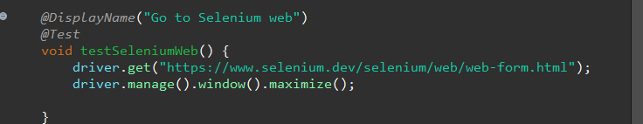

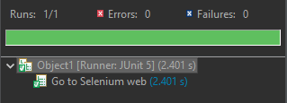

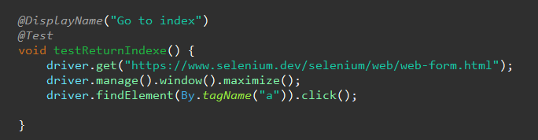

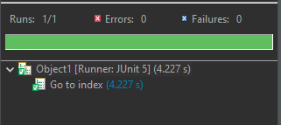

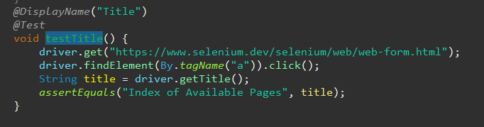

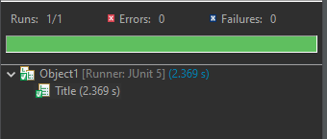

**Objective 2. (10%) This page must provide at least two textbox for inputting UserName and Password**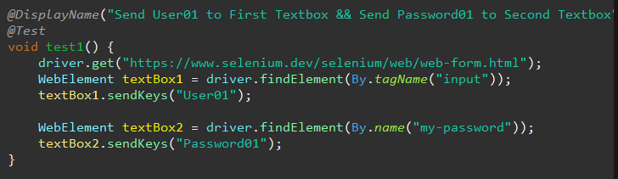

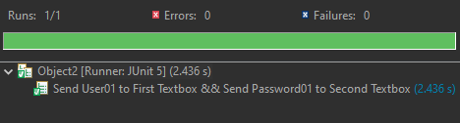

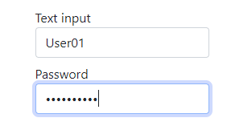

**Objective 3. (10%) This page must have a Dropdown, it also must have exactly 3 elements and there is a “two” values in one of these**

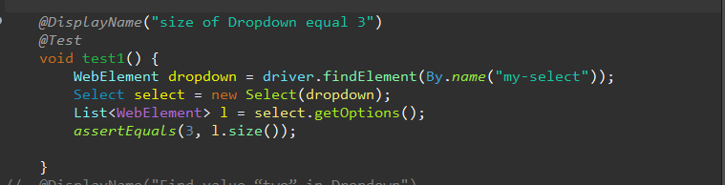

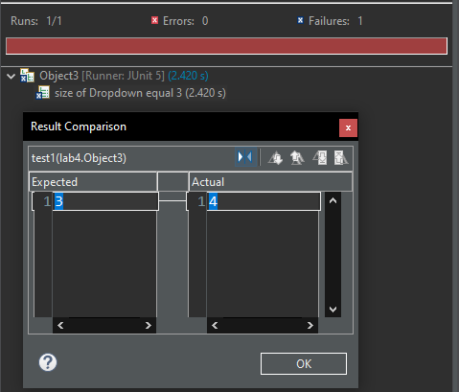

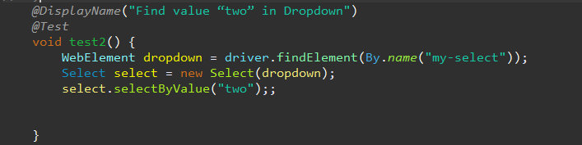

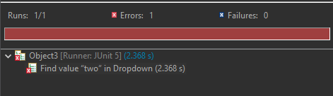

**Objective 4. (10%) Does this page have 2 Checkbox? Make sure they are all unchecked**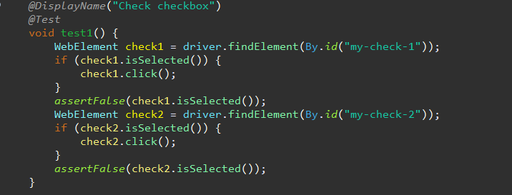

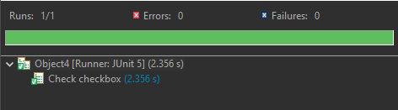

**Objective 5. (10%) This page must allow creating an account with a**

**fake email address.**

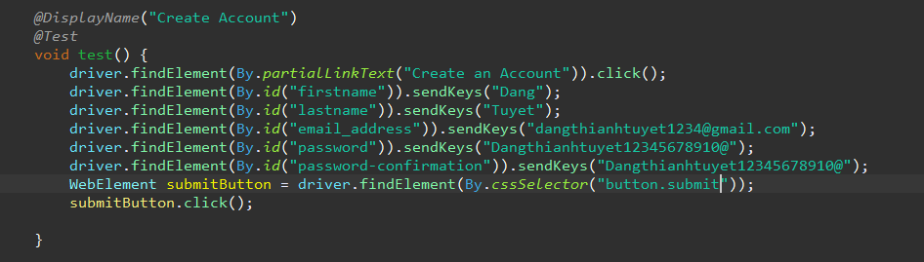

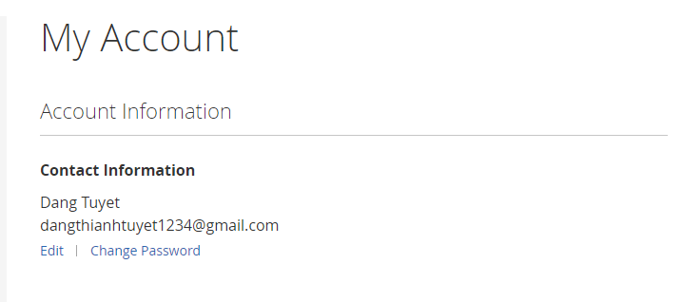

**Objective 6. (10%) User can’t login with a random account.**

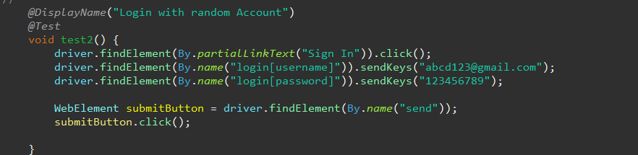

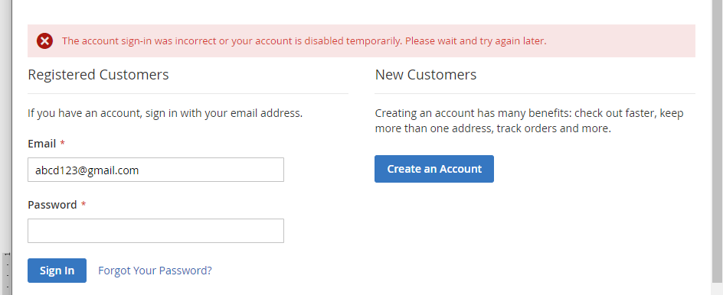

**Objective 7. (10%) This page allows User to search for a “Tank” then choose “Primo Endurance Tank” from the result.**

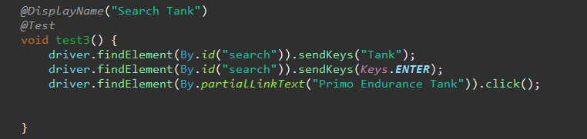

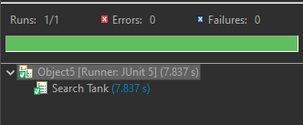

**Objective 8. (10%) This page allows User to add a product to their cart**

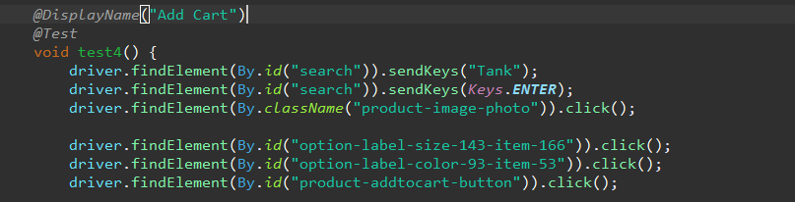

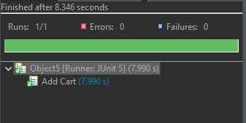

**Objective 9. (10%) You can check out then Place order after filling in all the necessary information.**